## Merchant

Demo date: Dec 3, 2024  
Scoping start date: Dec 3, 2024

MSA Signature Date: Dec 10, 2024  
Onboarding Kick Off Date: Jan 3, 2025

[If Exists] Opt Out Date: None  
Go Live Date:

Apr 30, 2025 No hard timeline. July Chargebee Renewal- they want to run parallel billing tracks beforehand

GTM POC: Paula  
Implementation POC: Dani

ERP: QBO

Tax Integration: Avalara

### 

### Key people at Merchant

### Accountant: Kelsey Dunn <https://www.linkedin.com/in/kelsey-dunn-cpa-263394b9/>

### CFO: Brian McCormick <https://www.linkedin.com/in/brianpmccormick/>

* + He currently took over the sales team

### Customer service rep who is really involved: N/A

* Account Receivable POC: **Kelsey Dunn** 
  + **Real accountant and will press on Rev Rec**
  + **Interested in running parallel cycles in Chargebee**
* Billing POC: Kelsey Dunn

### Renewals and Ops: Elizabeth **“Lizzie” Maierhofer** <https://www.linkedin.com/in/elizabeth-maierhofer-3001b0121/> >> Interested in the custom key terms parsing from the contract. Ask for Elizabeth to share the spreadsheet, discovery

### 

| Notes Sections [Ops International Team to Ignore] *(AE/ Implementation to fill)*   * Info on how merchant bills   + Typically Upfront Payment Terms   + Multiyear agreements   + 1400 customers. ~100 paid customers. Goal is to get to around 135-150 paid customers by EOY 2025 * Is there any important merchant relationship information?  1) What is the merchant temperament?   + Very nice and understanding   + Kelsey is more into the weeds and detail oriented   + Brian listens to his team’s opinion   + Brian recently just overtook the sales team   2) Is there a key POC: (i.e.: who is the buyer/decision maker?)   * Brian is the DM * Kelsey is the main end user 3) What are the Tabs features that the key POC cares about? * Brian- Rev rec, cash forecasting * Kelsey- invoicing and reporting * Lizzie- key terms, renewal clauses, renewal dash |
| --- |
|  |

### 

Company summary  
*(AE to fill)*

Summary of what company does:  
  
Medicom Technologies is a company that specializes in software solutions designed to support healthcare professionals in their clinical work. Primarily, Medicom provides electronic health record (EHR) systems and related healthcare technology. Their products aim to streamline the management of patient information and improve the quality of patient care through comprehensive and user-friendly digital solutions.  
Medicom’s systems are often used by physicians, clinics, and hospitals to record patient data, manage appointments, track medical histories, and enhance communication among healthcare providers. Their software platforms typically include features for patient scheduling, billing, clinical documentation, and reporting.

Goals (North star)  
*(AE/ Implementation to fill)*What is the merchant's goal? What pain are we solving? Why are they buying Tabs?

Goals:  
Why now:   
- they have a 2025 KPI to hit $10m in rev (currently at $6m) - they plan to bring on 35-50 customers with high ACV from their free tier → paid

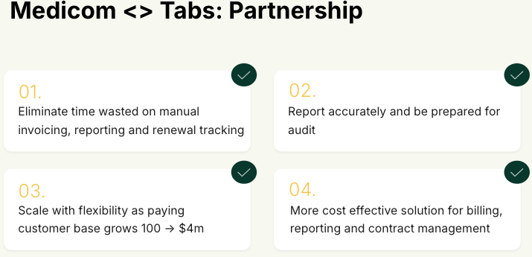

Pain:

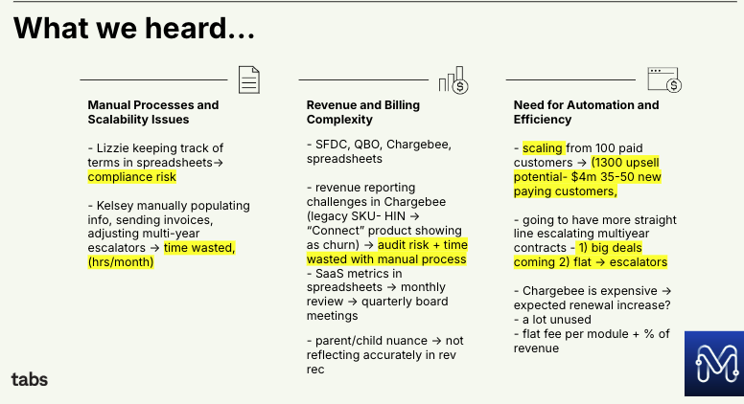

Is there an opt out clause? If so, what is the merchant looking for so they do not exercise it?

No

Billing model  
*(AE/ Implementation to fill)*

* Are there unique things about the customer creation process for this merchant?  
  - no
* Information on how merchant bills  
  - typically, annual upfront   
  - multiyear contracts
* How contract is broken up
* One off things to know about the merchant  
  - currently on Chargebee   
  - had a major issue with the reporting bc they have a few large ($1m) customers that they wouldn’t include in Chargbee due to Chargebee’s billing model. Therefore, their reporting would be inaccurate   
  - interest in custom key terms

### 

### 

### 

### 

### Contract Processing Steps *(Implementation/Success to fill)*

**Example of ORDER FORM (**[**Garage Example**](https://garage.tabsplatform.com/prod/contracts/1db285c0-61c0-471f-b349-770fe9f9320b/terms/revenue)**)** [**LOOM TRAINING RECORDING**](https://www.loom.com/share/9df067a216f14dc789265dd9f6c52f1a?sid=276a79c0-9879-4915-8882-0188b2cc4e9e)

* DO NOT CHANGE THE CUSTOMER IF IT MENTIONS “Uploaded on customer page”
* Service start date: Listed on Contract, see example in red text below
* Total months of service: Listed on Contract, see example in red text below
* Item name: Listed on Contract, see example in red text below
* Integration item: [Use **QBO Integration Item + Class** sheet](https://docs.google.com/spreadsheets/d/1GArOtUhu30AzpL1aC33zIcJJufu_KMXCdCOEvrtOYU0/edit?gid=623163753#gid=623163753) to see which one to map to
* **Assigned Class in QBO**: [Use **QBO Integration Item + Class**](https://docs.google.com/spreadsheets/d/1GArOtUhu30AzpL1aC33zIcJJufu_KMXCdCOEvrtOYU0/edit?gid=623163753#gid=623163753) sheet to see which one to map to
* Billing type: Flat
* Total price: use TOI escalation Google sheet to calculate and verify that each line item matches
  + Include discount under discount section not as a separate BT
  + [Example for Radnet](https://docs.google.com/spreadsheets/d/1DLDWB3NI1TVrlIdg42C34XoqjuqswB6vr_Qw0w72Zd0/edit?gid=0#gid=0)
* Quantity: Listed on Contract, see example in red text below
* Discount Amount: use TOI Escalation Google Sheet to calculate the discount
* Start Date: Refer to the Payment Schedule, create a different billing term for each payment schedule
* Periods: 1 if you are just doing 1 year per line item
* Frequency: Yearly if you are processing a yearly contract, read contract to see the billing frequency
* Net Terms: Defer to contract, if no net terms, Net 0
* Use Riverside Healthcare customer as an example for how products and discounts should be processed [Ashni Walia](mailto:ashni@tabsplatform.com):
  + 1 product in Tabs should agree to 1 contract (i.e. 1:1) - (understands there may need to be 2:1 for a customer given quarterly payments for example)
  + Discount sits on product itself
* Other things to note:
  + **Implementation should always have a 30 month revenue schedule**
  + If the payment schedule is for more than 1 year AND has different charges for each year, please flag to [Ashni Walia](mailto:ashni@tabsplatform.com)

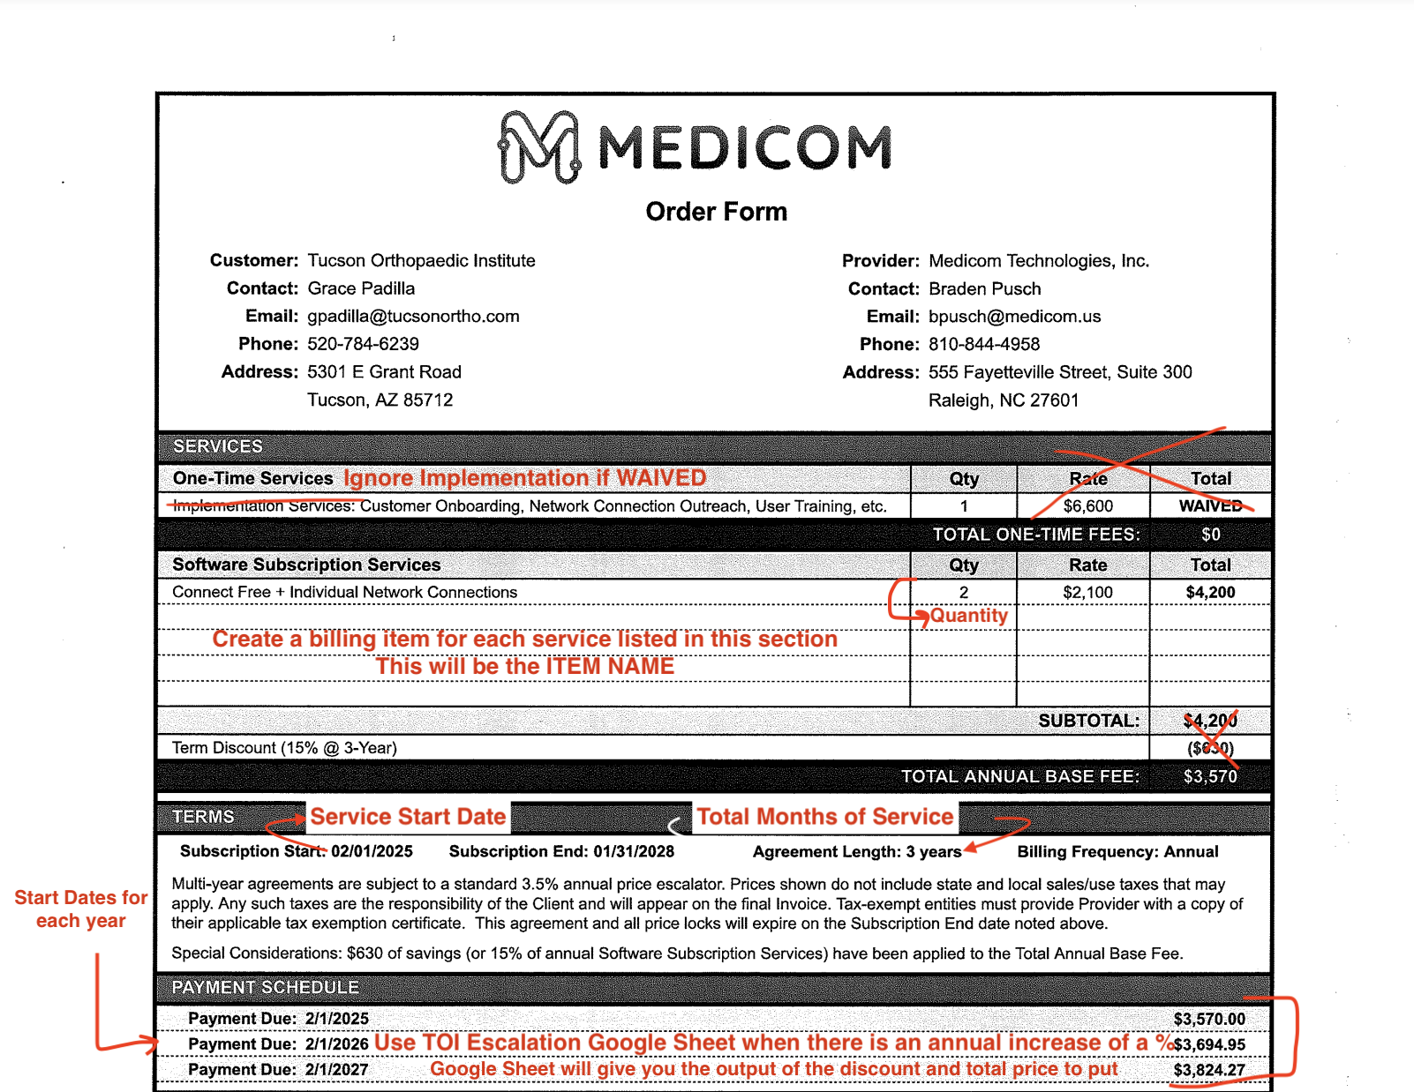

1. Anything to ignore in contracts?  
   Any waived fees
2. Specifics processing things the merchant has requested that may differ by contract (e.g. always back-date invoice date to final day of the month)

N/A

1. Default Service Term
   1. 3 years
2. Default Net Payment Terms
   1. Net0
3. Default Billing Frequency
   1. Annual
4. How do we handle taxes as a line item?
   1. No taxes

### Events Processing (if necessary) *(Implementation/Success to fill)*

* Any important information on events billing

Integration Items Processing (if necessary)  
*(Implementation/Success to fill)*

[*Medicom | Integration Items*](https://docs.google.com/spreadsheets/d/1hAm6M2PUfD3aCWywvikN6M2_dhFdwRsIUas2f4RnqQA/edit?gid=0#gid=0)

[*Merchant product page - Customer Facing Name*](https://docs.google.com/spreadsheets/d/1NaQmvmPBtTkk5otIcCtMJx0addX0JJAZ/edit?gid=2007851818#gid=2007851818)

* What are the instructions for assigning integration items?

***Important*** - reference the above Merchant product page document! The “Customer Facing Name” column is what is written into contract/SOW. Cross reference with the appropriate QBO product item. Most of the integration items should be mapped to ***-DR*** or ***DevRe***v in product name in QBO.

* Moving forward, all “Implementation Services should be mapped to the following (ID66):

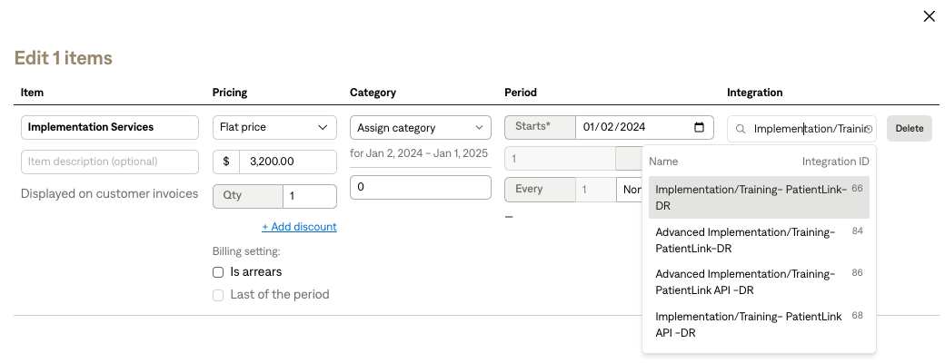

Post Processing Communications (if necessary)  
*(Implementation/Success to fill)*

* Does the Ops Team need to notify anyone on the team re: completion of processing batches in Implementation or Active phase?
* Who needs to be notified and when?
  + Example:
    - Who: Customer Success [Azmat Aziz] needs to be notified
    - Where: Messari internal merchant channel
    - When: contracts are processed [Merchant Phase: Active]

### Customer Information *(Implementation/Success to fill)*

* Any important information on specifics customers of this merchant
  + Special memo’s certain invoices require
  + Invoice changes due to merchant/customer relationship

### Feature Requests *(AE/Implementation/Success to fill)*

* FR 1
  + What is it
  + Why it's important
  + Urgency

### Rewatch Calls *(AE/Implementation/Success to fill)*

* Rewatch by dates